Ashing filters SOP
Before precombustion:
- Gi
Materials:
- Filters
- Muffle furnace
- Tinfoil
- Beakers (one for every foil packet made)
- Gloves
Place a glass beaker in the furnace and put the filters wrapped in aluminum foil on top of the beaker.
Put in the muffle furnace 400°C for 3 hrs.
Note: Place the filters on top of the beaker. If you put the filters directly on the surface of the furnace, they will melt and stick to each other.

Wrap the filters:
After donning clean gloves, tear a sheet of aluminum foil large enough to wrap two stacks of filters. Spread the aluminum foil on the counter. Open the filter box and ensure sure all the filters are stacked in their plastic casing- give a little shake to settle them out. Use their casing to gently invert the filter stack on to the aluminum foil. Divide the two stacks up by using their casing to move and center them. Double check if there is enough wrapping material. Carefully tear the foil in half (figure 1). Gently fold the aluminum foil over the stacks to cover them, being careful not to bend the edges.
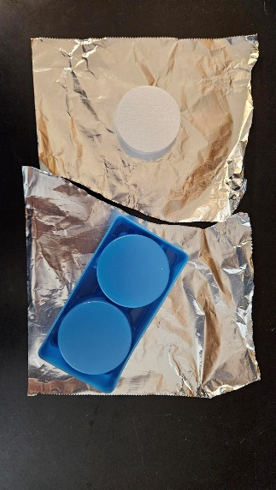
Figure 1: Preparing the filters be wrapped

Place in oven:
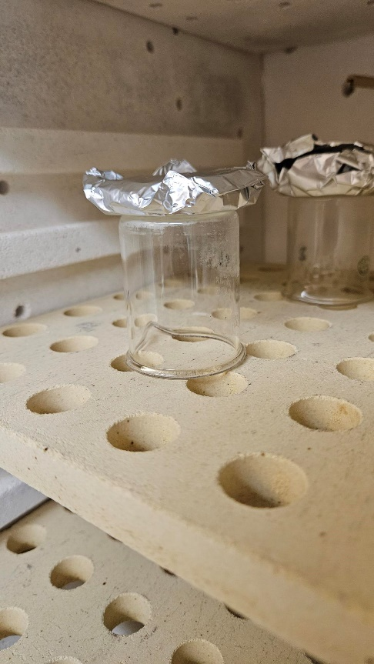
Use one beaker for every filter foil packet made. The beaker does not need to be “clean”, just wipe the bottom off if needed. There are some surplus beakers in the cabinet left of the FEWS acid washing cabinet. On the muffle furnace’s shelf place the beakers upside down and the filter foil packers on the top (figure 2). This is to ensure better heat distribution and prevent the filters from melting together.
Figure 2: Placement of filter foil packets in the furnace

Bake the filters:
The filters need to be baked for 3 hours at 400°C. The furnace takes around 30 minutes to reach temperature. Note: the dwell time is supposed to begin once the oven comes up to set temperature

Instructions for setting the oven:
- The circular arrow cycles through the setting options. Change the parameters using the up and down arrows
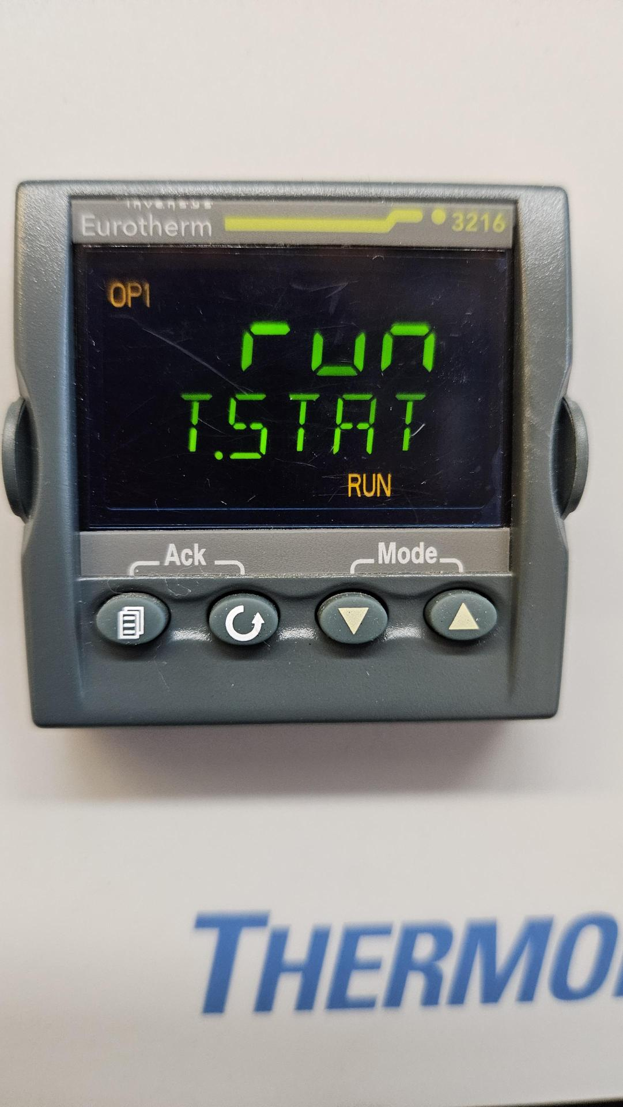
- Ensure the units are correct:
Cycle to TM.RES and select hours. Cycle to UNITS and select °C
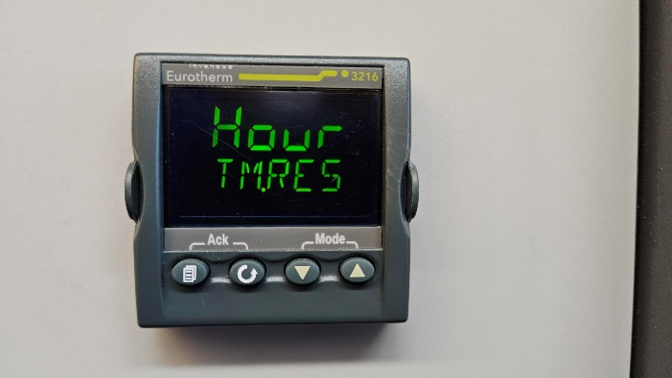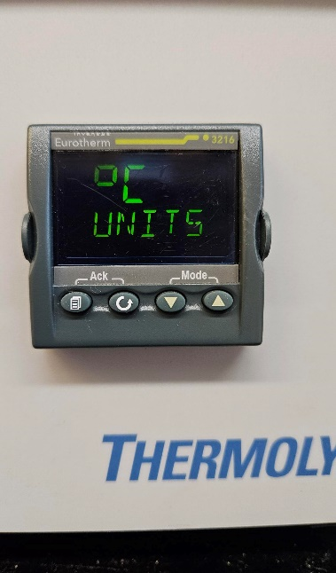
- Cycle to SPI and change the temperature to 400°C.
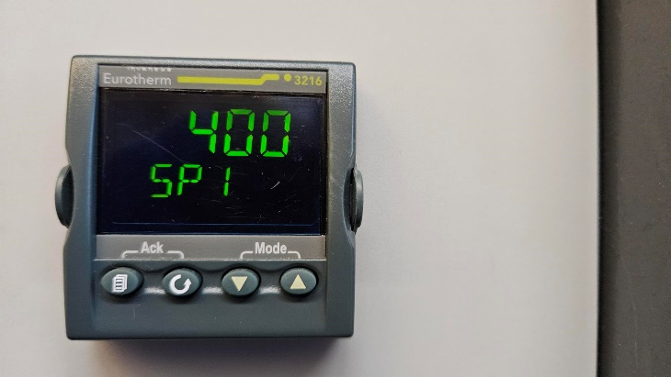
- Cycle to DWELL and change the temperature to dwell time to 3:00.
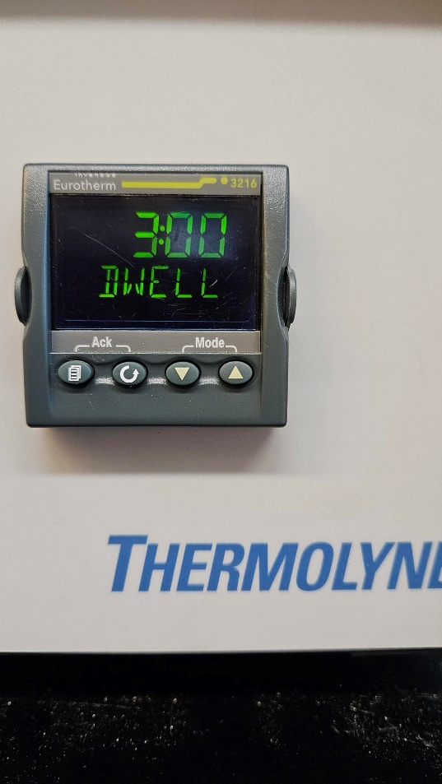
- Cycle to T.START and press the up button until RUN is selected. RUN and OPI will flash on screen in orange.
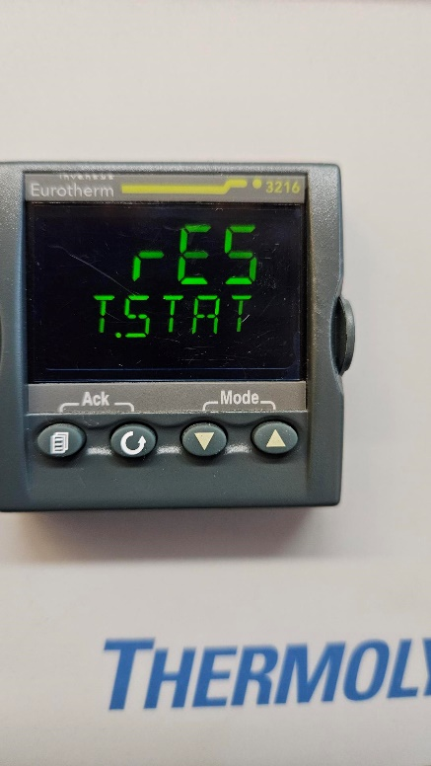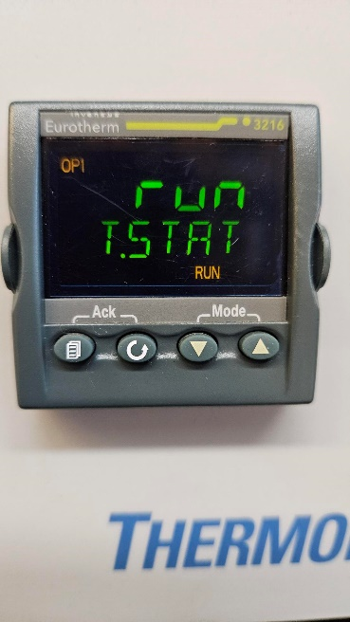

- Remember to fill out the muffle furnace maintenance record sheet.
- After dwell time has elapsed and materials are cool enough to handle put away beakers and place filter foil packets in a clean Ziplock labeled with “Ashed GFF filters”, today’s date, and “FEWS lab”.

